**The Gupta Empire**

From 320-550 CE, the Gupta Empire assimilated neighboring kingdoms, through conquest or political alliances.

**Learning Objectives**

Explain the factors that contributed to the rise of the Gupta Empire

**Key Points**

* Sri Gupta founded the Gupta Empire c. 240-280 CE, and was succeeded by his son, Ghatotkacha, c. 280-319 CE, followed by Ghatotkacha’s son, Chandragupta, c. 319-335 CE.
* After Chandragupta married princess Kumaradevi from the kingdom of Magadha, he conquered the nearby kingdoms and assumed the imperial title of  Maharajadhiraja, meaning “King of Kings.”
* Chandragupta’s son, Samudragupta, assumed the throne in 335 CE, and conquered several neighboring kingdoms; eventually, the Gupta Empire extended across the entire Indian subcontinent.
* Samudragupta was succeeded by his son, Chandragupta II, who continued to expand the Gupta Empire through conquest and political alliances.

**Key Terms**

* **Maharajadhiraja**: A Sanskrit title for “Prince of Princes” or “King of Kings,” several degrees higher than the title Maharaja, which means “Great King.”

The Gupta Empire, founded by Maharaja Sri Gupta, was an ancient Indian monarchy that covered much of the Indian Subcontinent from approximately 320-550 CE. Gupta rule, it expanded its territory through war, began a period of peace and prosperity marked by advancements in science, technology, engineering, art, dialectics, literature, logic, mathematics, astronomy, religion, and philosophy.

**Gupta Empire Origins**

The Gupta Empire was believed to be a dynasty of the Vaishya caste, the third of the four Hindu castes representing merchants and farmers. Founded by Sri Gupta c. 240-280 CE, there are contradictory theories regarding the original homeland of the Guptas. Historians believe Sri Gupta and his son may have been Kushan vassals, or rulers who swore allegiance to the Kushan Empire. Sri Gupta’s son and successor, Ghatotkacha, ruled from c. 280-319 CE, while his son, Chandragupta, ascended the throne around 319 and ruled until 335 CE.

Chandragupta married princess Kumaradevi from the Kingdom of Magadha, which was one of the Mahajanapadas (or great countries) of ancient India during the 4th century CE. With a dowry and political alliance from the marriage, Chandragupta conquered or assimilated the kingdoms of Magadha, Prayaga, and Saketa. By 321 CE, he established a realm stretching along the Ganges River to Prayag, the modern-day city of Allahabad, in the Indian state of Uttar Pradesh. Hindus believe the god Brahma offered his first sacrifice after creating the world at Prayag.

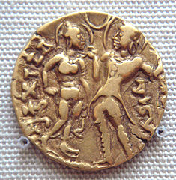

**Queen Kumaradevi and King Chandragupta I:** A coin from the period of Indian Emperor Samudragupta, 335-380 CE, depicting his parents, King Chandragupta and Queen Kumaradevi.

**Gupta Empire Expansion**

Samudragupta succeeded his father, Chandragupta I, in 335 CE, and ruled for about 45 years. He conquered the kingdoms of Ahichchhatra and Padmavati early in his reign, then attacked neighboring tribes, including the Malwas, Yaudheyas, Arjunayanas, Maduras, and Abhiras. By his death in 380 CE, Samudragupta had incorporated over 20 kingdoms into his realm, and extended the Gupta Empire from the Himalayas to the Narmada River in central India, and from the Brahmaputra River that cuts through four modern Asian nations to the Yamuna— the longest tributary of the Ganges River in northern India.

To celebrate his conquest, Samudragupta performed the royal Vedic ritual of *Ashwamedha*, or horse sacrifice. Special coins were minted to commemorate the Ashvamedha, and the king took the title of Maharajadhiraja (or “King of Kings”) even higher than the traditional ruler’s title of Maharaja.

According to the Gupta records, Samudragupta nominated his son, Prince Chandragupta II, born of Queen Dattadevi, as his successor. However, his eldest son, Ramagupta, may have been his immediate successor until he was dethroned by Chandragupta II in 380 CE.

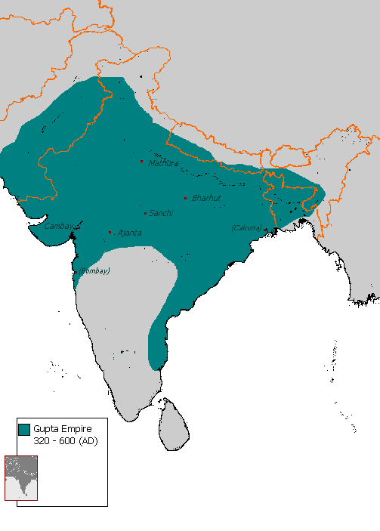

**Gupta Empire, 320-600 CE:** The Gupta Empire expanded through conquest and political alliances until 395 CE, when it extended across the entire Indian subcontinent.

**Gupta Empire of Chandragupta II**

After gaining power, Chandragupta II expanded the Gupta Empire through conquest and political marriages until the end of his reign in 413 CE. By 395 CE, his control over India extended coast-to-coast. At the high point of his rule, Chandragupta II established a second capital at Ujjain, the largest city in the modern state of Madhya Pradesh in central India. Ujjain, on the eastern bank of the Kshipra River, remained an important political, commercial, and cultural hub through the early 19th century.

Vikramaditya is the name of an emperor of ancient Indian legend, characterized as the ideal king known for generosity, courage, and as a patron of scholars. A number of historians believe that some of these legends are based on Chandragupta II, who is thought to have adopted the title of Vikramaditya.

In the legends, Vikramaditya is said to have thwarted an invasion by the Saka, a group of eastern Iranian nomadic tribes, also known as Scythians, and gained the title of Sakari, or Enemy of the Saka. Chandragupta II conquered the western Indian region of Malwa after defeating the Western Kshatrapas, a branch of the Sakas, as well as expelling the Kushana Empire from the northern Indian city state Mathura. These victories were likely transposed onto the legendary character of Vikramaditya.

Chandragupta II issued gold coin types introduced by his father, Samudragupta, but also introduced several new types of coins, differentiated by the designs on the face of each coin line, such as the Archer or the Tiger-Slayer. He was also the first Gupta king to issue silver coins.

One of the most curious structures in Delhi, India (an iron pillar dating back to the 4th century CE) bears an inscription stating that it was erected as a flagstaff in honor of the Hindu god Vishnu, and in memory of Chandragupta II. The pillar, made of 98% wrought iron, is considered a highlight of ancient Indian achievements in metallurgy; it has stood more than 1,600 years without rusting or decomposing.

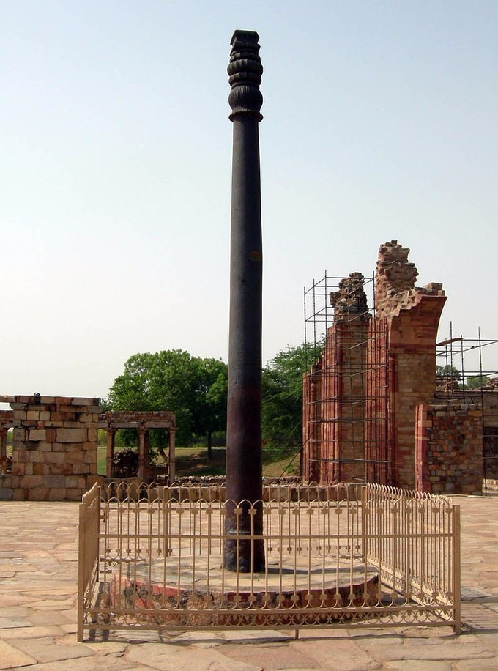

**Iron Pillar of Delhi**: The Iron Pillar of Delhi, India, erected by Chandragupta II to honor the Hindu god Vishnu, in the 4th century CE.

Despite the expansion of the Gupta Empire through war, there were numerous examples of cultural sophistication during the Gupta era, with architecture, sculptures and paintings surviving as reminders of the creativity of the time. Under Gupta rule, a number of notable scholars thrived, including Kalidasa, considered the greatest poet and dramatist of the Sanskrit language; Aryabhata, the first of the Indian mathematician-astronomers who worked on the approximation for *Pi*; Vishnu Sharma, thought to be the author of the *Panchatantra* fables, one of the most widely-translated, non-religious books in history; and the Hindu philosopher Vatsyayana, author of the *Kama Sutra*.

The period of Gupta rule, especially the reign of Chandragupta II, is still remembered as the Golden Age of India.

**The Golden Age of India**

The prosperity of the Gupta Empire produced a golden age of cultural and scientific advancements.

**Learning Objectives**

Understand the significance of the Golden Age of India

**Key Takeaways**

**Key Points**

* Prosperity in the Gupta Empire initiated a period known as the Golden Age of India, marked by extensive inventions and discoveries in science, technology, engineering, art, dialectic, literature, logic, mathematics, astronomy, religion, and philosophy.
* Chandragupta II promoted the synthesis of science, art, philosophy, and religion, in part because his court contained the Navartna, or the Nine Jewels, a group of nine scholars who produced advancements in many academic fields.
* Chinese traveler Fa Xian visited India from 399-405 CE, during the reign of Emperor Chandragupta II. He recorded all of his observations in a journal that was later published.

**Key Terms**

* **Golden Age of India**: A period at the height of the Gupta Empire, marked by extensive inventions and discoveries that contributed to Hindu culture, in subjects such as science, technology, engineering, art, dialectic, literature, logic, mathematics, astronomy, religion, and philosophy.
* **Chandragupta II**: His reign, from 375-415 CE, promoted the synthesis of science, art, philosophy, and religion during the Golden Age of India.
* **Fa Xian**: A Chinese traveler who recorded detailed observations about his experience in the Gupta Empire in his journal. It was later published.
* **Navartna**: Also called the Nine Jewels; a group of nine scholars in the court of Chandragupta II who contributed many advancements in their academic fields.
* **ayurvedic**: A form of alternative medicine established in India.

The prosperity created under the leadership of the Gupta Empire, which covered much of the Indian subcontinent from approximately 320-550 CE, enabled the wide pursuit of scientific and artistic endeavors. This period became known as the Golden Age of India because it was marked by extensive inventions and discoveries in science, technology, engineering, art, dialectic, literature, logic, mathematics, astronomy, religion, and philosophy. These discoveries crystallized elements of what is generally considered Hindu culture.

\*\*\*\*\*\*\*\*\*\*\*\*\*\*\*\*\*\*\*\*\*\*\*\*\*\*\*\*\*\*\*\*\*\*\*\*\*\*\*\*\*\*\*\*\*\*\*\*\*\*\*\*\*\*\*\*\*\*\*\*\*\*\*\*\*\*\*\*

**Science, Literature, and Art**

Although Chandragupta I and his son, Samudragupta, were prominent rulers, the reign of Chandragupta II included the greatest promotion of science, art, philosophy, and religion by the government. Chandragupta’s court was even more influential than those that came before or after because it contained the Navaratnas, or the Nine Jewels, a group of nine scholars who produced advancements in many academic fields.

These scholars included Aryabhata, who is believed to have envisioned the concept of zero, as well as working on the approximation for the long-form number Pi. Aryabhata is also believed to be the first of the Indian mathematician-astronomers who postulated the theory that the Earth moves round the Sun and is not flat, but instead is round and rotates on its own axis. He also may have discovered that the moon and planets shine due to reflected sunlight.

Varahamihira was an astronomer, astrologer, and mathematician, whose main work is a treatise on mathematical astronomy. Sushruta, a famed Indian physician of the Gupta period, wrote the *Samhita*, a Sanskrit text on all of the major concepts of ayurvedic medicine, with innovative chapters on surgery. Other scholars of the Golden Age helped create the first Indian numeral systems with a base of ten. The game of chess also likely originated during this period, where its early form, *Chaturanga*, contained game pieces for infantry, cavalry, elephants, and chariots, each of which would evolve into the modern pawn, knight, rook, and bishop, respectively.

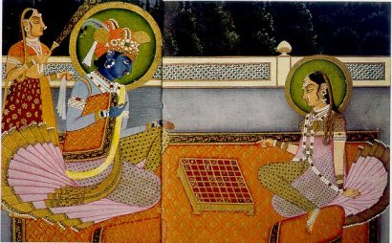

**Krishna and Radha playing Chaturanga:** Scholars during the reign of Chandragupta II contributed many scientific advancements in the fields of astronomy, mathematics, and medicine.

Kalidasa, considered the greatest poet and dramatist of the Sanskrit language, also belonged primarily to this period. He wrote plays, such as *Shakuntala*, which is said to have inspired the famed German writer and statesman, Johann von Goethe, centuries later. Kalidasa also became renowned for his study of the *shringara*, or romantic, element of literature. The Indian scholar and Hindu philosopher Vatsyayana, authored the *Kama Sutra*, which became a standard work on human sexual behavior, while Vishnu Sharma was thought to be the author of the *Panchatantra* fables, one of the most widely-translated, non-religious books in history.

The cultural creativity of the Golden Age of India produced magnificent architecture, including palaces and temples, as well as sculptures and paintings of the highest quality. The walls of Buddhist shrines and monasteries were decorated with colorful frescoes, a type of wall paintings. These showed scenes from the life of the Buddha, the ascetic and philosopher, who lived in the eastern part of the Indian subcontinent sometime between 6th and 4th centuries, on whose teachings the Buddhist religion is based. Some shrines were cut out of the cliffs, and although dark, they were also decorated with sculptures and paintings.

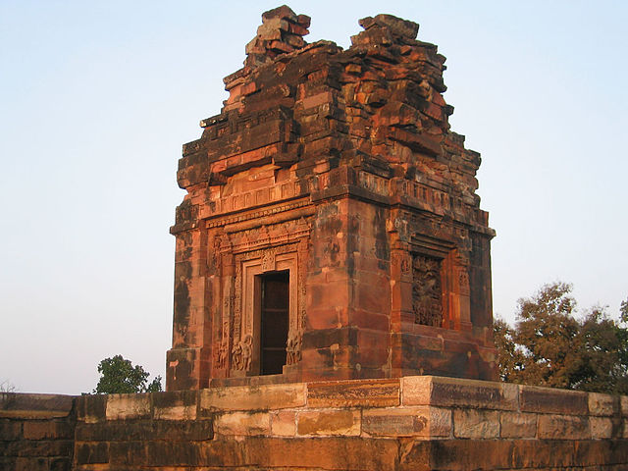

**The Dashavatara Temple:** The Golden Age of India produced many temples, decorated with various sculptures and paintings, such as the Dashavatara Temple, also known as the Vishnu Temple, in central India.

**Influence on East and Southeast Asia**

The Gupta Dynasty promoted Hinduism, but supported Buddhist and Jain cultures as well. Gupta Buddhist art influenced East and Southeast Asia as trade between regions increased. The Gupta Empire became an important cultural center and influenced nearby kingdoms and regions in Burma, Sri Lanka, and Southeast Asia. Classical forms of Indian music and dance, created under the Guptas, are still practiced all over Asia today.

Fa Xian was one of the first Chinese travelers to visit India during the reign of Gupta Emperor Chandragupta II. He started his journey from China in 399 CE, and reached India in 405 CE. He recorded all of his observations in a journal that was eventually published.

During his stay in India, until c. 411 CE, Fa Xian went on a pilgrimage to Mathura, Kanauj, Kapilavastu, Kushinagar, Vaishali, Pataliputra, Kashi andRajgriha. His writings express pleasure in the mildness of the administrations in these places.

**Decline of the Gupta Empire**

After many years of dominance, the Gupta Empire collapsed in 550 CE, due to invasions and weak leadership of successive rulers.

**Learning Objectives**

Understand the decline of the Gupta Empire

**Key Points**

* The Gupta Empire flourished under Chandragupta II, but began to falter under his son, Kumaragupta, and grandson,Skandagupta.
* The Huna People, also known as Huns, invaded Gupta territory and caused significant damage to the empire.
* The Gupta Empire ended in 550 CE, when it disintegrated into regional kingdoms after a series of weak rulers and invasions from the east, west, and north.

**Key Terms**

* **Chandragupta II**: The emperor of the Gupta Dynasty of ancient India from c. 380-415 CE.
* **Kumaragupta I**: Son of Chandragupta II; the emperor of the Gupta Dynasty from c. 415-455 CE.
* **Skandagupta**: Son of Kumaragupta I; the emperor of the Gupta Dynasty from c. 455-467 CE.
* **Huna**: A Central Asian Xionite tribe that consisted of four hordes that repeatedly invaded Gupta territory, and helped cause the downfall of the Gupta Empire.

The Gupta Empire flourished, in military and territorial conquests as well as cultural and scholastic advancements, during the reign of Emperor Chandragupta II. Yet the succeeding rulers, beginning with Kumaragupta I and then Skandagupta, oversaw the eventual end of the Gupta Empire through military defeats, devalued money and withering leadership.

**Kumaragupta**

In 415 CE, Chandragupta II was succeeded by his second son, Kumaragupta I, who ruled successfully until 455 CE. The late years of his reign, however, faced difficulties. The Pushyamitras, a tribe of central India, rose up in rebellion against Kumaragupta, while Gupta territories were invaded by the Western Huna people, also known as White Huns.

Kumaragupta defeated both groups and celebrated his victory by performing the royal Vedic ritual of Ashwamedha, or horse sacrifice, which had previously been performed by his grandfather, Emperor Samudragupta, to celebrate his own great military victories.

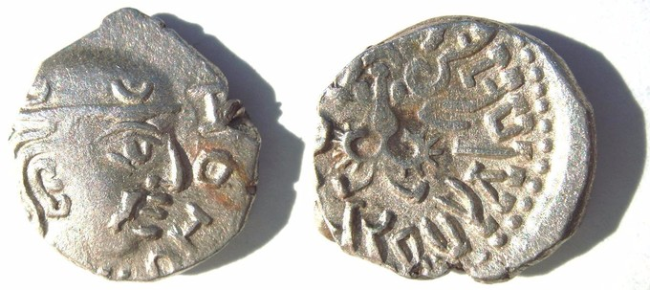

**Coin of Kumaragupta I:** A silver coin from the reign of Gupta Emperor Kumaragupta I, c. 415-455 CE.

As his grandfather and father did before him, Kumaragupta also issued news coins to mark his reign. They were stamped with images of his namesake god, Lord Kumara, regarded by Hindus as Regent of Earth.

**Skandagupta**

Upon Kumaragupta’s death in 455 CE, his son, Skandagupta, assumed the throne and ruled until c. 467 CE. He is considered the last of the great Gupta rulers prior to the collapse of the empire.

Skandagupta, who was celebrated as a great warrior for his victorious clashes with the Huns during his father’s reign, defeated several rebellions and external threats from the Huna people, notably an invasion in 455 CE. Although victorious, the expenses of the wars against the Hunas drained the empire’s resources. The value of the coinage issued under Skandagupta becoming severely reduced.

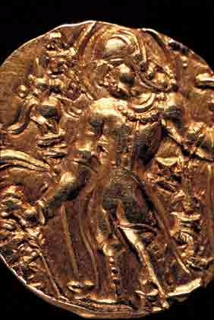

**Coin of Skandagupta:** A coin emblazoned with the image of Gupta Dynasty Emperor Skandagupta, who ruled c. 455-467 CE.

**The Huna and Gupta’s Demise**

The Huna were a Central Asian Xionite tribe that consisted of four hordes: Northern Huna, also known as the Black Huns; Southern Huna, the Red Huns; Eastern Huna, the Celestial Huns; and the White Huns, the Western Huna. The White Huns, those who invaded the Gupta Empire during the reign of Kumaragupta, were also known as the Hephthalites, and caused great damage to the failing Gupta Empire. Skandagupta died in 467 CE, and was followed onto the throne by his half-brother, Purugupta, who ruled from 467-473 CE.

Thereafter came a succession of weak kings, beginning with Kumaragupta II from 473-476 CE, followed by Budhagupta, the son of Purugupta. The Hephthalites broke through the Gupta military defenses in the northwest in the 480s, during the reign of Budhagupta, and by 500 CE much of the empire in northwest was overrun by the Huna.

The empire thereafter disintegrated into numerous regional kingdoms, ruled by chieftains. A minor line of the Gupta Clan continued to rule Magadha, one of the 16 Indian Mahajanapadas, or “Great Countries,” but the Gupta Empire fell by 550 CE.

\*\*\*\*\*\*\*\*\*\*\*\*\*\*\*\*\*\*\*\*\*\*\*\*\*\*\*\*\*\*\*\*\*\*\*\*\*\*\*\*\*\*\*\*\*\*\*\*\*\*\*\*\*\*\*\*\*\*\*\*\*\*\*\*\*\*\*\*\*\*\*\*  
**Sasanka**

-- First independent king of Gaur

-- Capital at Karnasubarna (Murshidabad)

-- Ruled from end of 6th / beginning of 7th century to 650.

-- Hsuen Tsang depicted Sasanka as anti-Buddhist.

-- Invaded Magadha (Southern Bihar) and forerunner of aggressive policy followed by Dharmapala.

**Matsanayam**

* period of anarchy between 650 – 750;
* Following the century, after the death of Sasanka, Bengal saw very little of stable government and the whole country was torn by internal strife and disturbed by invasions from outside.
* This found mention in the Pala records as state of matsyanyaya

**Pala Dynasty:**

After the death of Harshavardhana, many kingdoms arose in North and Eastern India. After the fall of the Gauda King Shashanka, there was anarchy in the region forming Bengal. The Pala kingdom had a close relationship Southeast Asia particularly the Sri Vijaya Empire in Sumatra. It also had links with the Tibetan Empire and the Arab Abbasid Caliphate.

Origins

* Gopala founded the dynasty in 750 AD.
* He was a chieftain or military general who was elected as king by notable men of the area to prevent anarchy.

Rulers

Gopala (Reign: 750 – 770 AD)

* First Pala king and founder of the dynasty.
* Son of Vapyata, a warrior.
* Was elected by a group of people.
* At the time of his death, Pala kingdom included Bengal and most of Bihar.
* He built the monastery at Odantapuri, Bihar.
* Considered the first Buddhist king of Bengal.

Dharmapala (Reign: 770 – 810 AD)

* Son and successor of Gopala.
* Expanded the kingdom.
* Was a pious Buddhist.
* Founded the Vikramshila University at Bhagalpur, Bihar.
* He had frequent wars with the Pratiharas and the Rashtrakutas.
* The Palas became the most powerful kingdom in northern and eastern India during his rule.

Devapala (Reign: 810 – 850 AD)

* Son of Dharmapala and Rannadevi, a Rashtrakuta princess.
* Extended the kingdom to Assam, Odisha and Kamarupa.
* Was a staunch Buddhist and built many monasteries and temples in Magadha.
* Defeated the Rashtrakuta ruler Amoghavarsha.

Mahipala I

* Ascended the throne in 988 AD.
* Recovered northern and eastern Bengal.
* Also took Bihar.

Ramapala

* The last strong Pala king.
* The kingdom disintegrated during his son Kumarapala’s reign.

Madanapala (Reign: 1144 – 1162 AD)

* The last Pala king.
* After him, the Sena dynasty replaced the Palas.

Legacy of the Pala Dynasty

* The Pala Empire was dethroned by the Hindu Sena dynasty in the 12th century.
* The Pala period is also known as a ‘Golden Era’ in Bengali history.
* They built magnificent monasteries and temples: Somapura Mahavihara (in Bangladesh), Odantapuri Monastery.
* They also patronised Buddhist centres of learning like Nalanda University and the Vikramshila University.
* During this time, the Bengali language developed. The first Bengali literary work Charyapada is attributed to this period. It was written in an Abahatta (the common ancestor of Bengali, Assamese, Odia and Maithili.
* Balaputradeva, the Sailendra king of Java sent an ambassador to Devapala.
* Buddhist poet Vajradatta who composed Lokesvarashataka was in Devapala’s court.
* Many Buddhist teachers from the Pala kingdom travelled to Southeast Asia to spread the faith. Atisha preached in Sumatra and Tibet.
* Sanskrit scholars were also patronised by the Pala kings. Gaudapada composed Agama Shastra during the time of the Palas.
* The Pala art (art seen in Bengal and Bihar during the Pala regime) influence is seen in the art of Nepal, Sri Lanka, Burma and Java.

\*\*\*\*\*\*\*\*\*\*\*\*\*\*\*\*\*\*\*\*\*\*\*\*\*\*\*\*\*\*\*\*\*\*\*\*\*\*\*\*\*\*  
**What were the achievements of the Pala dynasty?**

Some rare accounts from old history books or national libraries which are not easily accessible online would be welcome.

Pala Dynasty:

1. In this period only, feudal economy introduced, where trade declined and agro economy flourished.

2. Minerals played a major role in uplifting the economy.

3. They have monarchial administration and so, the society was very peaceful during that period.

4. They followed Buddhism and Hinduism as their major religion.

5. Art and Architecture were encouraged with the help of "Pala school of Sculptural Art".

6. They had done great works like Vikramshila Vihar, Odantpuri Vihar, Jagaddal Vihar.

7. They used Proto-Bengal Language for their communication.

8. The Pala Rulers were very much interested in Buddhist art, literature and learning.

9. Bengali art, literature and paintings flourished during this period.

\*\*\*\*\*\*\*\*\*\*\*\*\*\*\*\*\*\*\*\*\*\*\*\*\*\*\*\*\*\*\*\*\*\*\*\*\*\*\*\*\*\*\*\*\*\*\*\*\*\*\*\*\*\*\*\*\*\*\*\*\*\*\*\*\*\*\*\*\*\*\*\*\*  
  
**The Sena Dynasty**

The Sena Dynasty of Bengal belonged to the Brahmana-Kshatriya clan of Karnata in South India. After the palas, Senas became the ruler of Bengal.

The remote ancestor of the Sena Dynasty was one Virsena whose name we have found in the Puranas. The Senas were known as the Brahma-Kshatriya as because they were at first Brahmin but became Kshatriya afterwards.

Samantasena was a noted general who distinguished himself in various wars in South India. In his old age he settled at Radha in Bengal and laid the foundation of future greatness of the family.

## King Hemanta Sena – Founder of Sena Dynasty in Bengal

His son Hemanta Sena took the title of Maharajadhiraj and founded an independent kingdom in Radha taking advantage of the disintegration of the Pala Empire by the Kaivartha revolt of Divya. Raja Hemanta Sena  is believed to be the founder of Sena Dynasty. From Radha the Senas gradually extended their empire to the other parts of Bengal.

How the Senas came in Bengal and captured the royal power is not known to us clearly. Possibly they came to Bengal along with the invading army of Chalukya king Vikramaditya VI. According to some scholars when Rajendra Cholas army invaded Bengal the Senas accompanied them and might be some Karnata official of the Palas established an independent kingdom at Radha taking advantage of the weakness of their master.

## Sena Empire under Raja Vijay Sena

Raja Vijay Sena was the son of  Hemanta Sena. He was a very powerful ruler of Sena Empire. He elevated the Sena Empire into the position of the rulers of the whole of Bengal and adjoining provinces. He ruled for a long period of 60 years. He was a shrewd opportunist and calculated meddling in contemporary politics had enabled him to become the master of whole Radhadesa from the position of a petty chief of a small kingdom of Radha. Possibly he helped Rampala against Bhima in exchange of territory and money. His marriage to the princess of Sara family had also increased his power.

After the death of Rampala, Vijaysena made an attempt to conquer the whole of Bengal. He made an alliance with the Kalinga king, Ananta Varmana Chodaganga and became the lord of Radha desa. From thereon he proceeded to conquer Gauda and Northern Bengal from the Palas. At that time the Mithila king was also trying to invade Gauda. Vijaysena defeated the Mithila king Nanyadeva and faced Madanpala, the Pala king of Gauda to leave Gauda and retire to Magadha. The Deopara inscription proves that with this success he acquired the greater part of Gauda or Northern Bengal.

Following the conquest of Gauda, Vijaysena extended his authority over Vanga or Eastern Bengal by overthrowing King Bhojavarmana of Varmana dynasty. Thus he became the master of whole Bengal. Not only in Bengal, had Vijaysena also extended his empire in other neighboring provinces also. From his Deopara inscription we came to know that he also defeated the kings of Kamrupa and Kalinga. His grandson Lakshmanasena assisted him in, these campaigns. Probably, Vijaysena conquered a portion of North Bihar also.

The long and prosperous reign of Vijaysena was a momentous episode in the history of Bengal. The establishment of a strong and powerful monarchy by Vijaysena put an end to the internal chaotic condition and stopped further foreign invasions that had disturbed the people of Bengal during the close of the Pala regime. The poetical composition of Umapatidhara in the Deopara Prasasti and the Vijay Prasasti of Sir Harsha revealed his glory.

## **Sena Empire under Ballal Sena**

Vijaysena died in 1158 and was succeeded by his son Vallala Sena (Ballal Sena). His period was of peace and social reform. The literary and other traditions, however, speak that Vallala Sena conquered Magadha and Mithila in Bihar. His kingdom consisted of Bengal and Northern Bihar. He was a learned scholar and wrote two famous works—Danasagara and Adbhutsagara. He revived the orthodox Hindu rites and various social reforms including the introduction of Kulinism in Bengal.

## Sena Empire under Lakshmana Sena

Lakshmana Sena succeeded his father Vallala Sena in 1179 at an advanced age of 60. He was by faith a Vaishnava and assumed Vaishnavite title. The epigraphic and literary sources credited him of many victorious campaigns. He defeated the Kings of Gauda, Kamrupa, Kalinga and Kasi. King Lakshmana Sena planted the pillars of victory at Puri, Benaras and Allahabad. Lakshmanasena, however, did not undertake any new campaign against these countries. Lakshmanasena’s significant success was against these Gahadavalis who overthrew the Palas from Magadha. Lakshmana Sena defeated Jayachandra Gahadavala from Magadha and carried campaign against Benaras and Allahabad. This conquest is proved by the prevalence of Lakshmana Samvat in North Bihar. He had a struggle against the Kalachuris of the West.

However, by the end of 12th Century the Sena kingdom began to disintegrate due to internal revolts and external invasion. Dommanapala established an independent kingdom at Khadi, Mandala or 24 Parganas. The Deva family also established an independent kingdom at the eastern coast of Meghna.

In 1202 Muhammad Bakhtiyar a soldier of fortune invaded Bengal and captured Nadia the Capital city of Lakshmanasena. Lakshmanasena fled to West Bengal and conquering Nadia Bakhtiyar afterwards shifted his seat of government to Lakhnawati. Even after the loss of Nadia, Lakshmanasena ruled for some more years over Eastern Bengal and Southern Bengal. He probably died in 1205 A.D. He was a great soldier and the last great Hindu ruler in Bengal. He was a great poet and patron of arts and letters. Some of his verses are included in Sadukti karnamrita. He completed his father’s unfinished text of Adbhutasagara. The famous poets like Jaideva, the author of Gitagovinda, the Dhoyi the author of Pavanaduta and scholars like Halaydha, Sridhara Das etc. were in his court.

Vishwarup Sena was the 5th ruler of Sena Dynasty.  Keshav Sena was the 6th and the last ruler of Sena Dynasty.

**Inscriptions**

A copperplate was found in the Adilpur or Edilpur [pargana](https://www.revolvy.com/topic/Pargana&item_type=topic) of [Faridpur District](https://www.revolvy.com/topic/Faridpur%20District&item_type=topic) in 1838 A.D. and was acquired by the [Asiatic Society of Bengal](https://www.revolvy.com/topic/Asiatic%20Society%20of%20Bengal&item_type=topic), but now the copperplate is missing from collection. An account of the copperplate was published in the Dacca Review and Epigraphic Indica. The copperplate inscription is written in [Sanskrit](https://www.revolvy.com/topic/Sanskrit&item_type=topic) and in [Ganda](https://www.revolvy.com/topic/Ganda%20language&item_type=topic) character, and dated 3rd [jyaistha](https://www.revolvy.com/topic/Joishtho&item_type=topic) of 1136 samval, or 1079 A.D. In the Asiatic Society's proceeding for January 1838, an account of the copperplate states that three villages were given to a [Brahman](https://www.revolvy.com/topic/Brahman&item_type=topic) in the third year of [Keshava Sena](https://www.revolvy.com/topic/Keshava%20Sena&item_type=topic). The grant was given with the landlord rights, which include the power of punishing the chandrabhandas or [Sundarbans](https://www.revolvy.com/topic/Sundarban&item_type=topic), a race that lived in the forest.[10] The land was granted in the village of Leliya in the Kumaratalaka mandala, which is situated in shatata-padamavati-visaya. The copperplate of [Keshava Sena](https://www.revolvy.com/topic/Keshava%20Sena&item_type=topic) records that the king Vallala Sena carried away, from the enemies, the goddesses of fortune on palanquins ([Shivaka](https://www.revolvy.com/topic/Ashvamedha&item_type=topic" \o "Ashvamedha" \t "_blank)), which elephant tusk staff supported; and also states that Vallala Sena's son, Lakshmana Sena (1179–1205), erected pillars of victory and sacrificial posts at Varanasi, Allahabad, and Adon Coast of the South Sea. The copperplate also describes the villages with smooth fields growing excellent paddy, the dancing and music in ancient Bengal, and ladies adorned with blooming flowers. The Edilpur copperplate of Keshava Sena records that the king made a grant in favour of Nitipathaka Isvaradeva Sarman for the inscae of the subha-varsha.

The [Deopara Prashasti](https://www.revolvy.com/topic/Deopara%20Prashasti&item_type=topic) is a stone inscription eulogising the Sena kings, particularly [Vijaya Sena](https://www.revolvy.com/topic/Vijaya%20Sena&item_type=topic), composed by the court poet Umapati Dhara.

**Society**

The Sena rulers consolidated the caste system in Bengal. Although Bengal borrowed from the caste system of [Mithila](https://www.revolvy.com/topic/Mithila%20%28ancient%29&item_type=topic), caste was not so strong in Bengal as in Mithila.[11]

**Architecture**

The Sena dynasty is famous for building [Hindu temples](https://www.revolvy.com/topic/Hindu%20temple&item_type=topic) and monasteries, which include the renowned [Dhakeshwari Temple](https://www.revolvy.com/topic/Dhakeshwari%20Temple&item_type=topic) in what is now [Dhaka](https://www.revolvy.com/topic/Dhaka&item_type=topic), Bangladesh. In Kashmir, the dynasty also likely built a temple, which is ascribed to a Gaureshwara or Ballala Sena.[12]

**Literature**

The Sena rulers were also great patrons of literature. During the Pala dynasty and the Sena dynasty, major growth in [Bengali](https://www.revolvy.com/topic/Bengali%20language&item_type=topic) was witnessed. Some Bengali authors believe that [Jayadeva](https://www.revolvy.com/topic/Jayadeva&item_type=topic), the famous Sanskrit poet and author of [Gita Govinda](https://www.revolvy.com/topic/Gita%20Govinda&item_type=topic), was one of the Pancharatnas (five gems) in the court of Lakshmana Sena. [Dhoyin](https://www.revolvy.com/topic/Dhoyin&item_type=topic) – himself an eminent court poet of Sena dynasty – mentions nine gems (ratna) in the court of Lakshmana Sena, among whom were:

* Govardhana
* Sarana
* Jayadeva
* Umapati
* Dhoyi/ [Dhoyin](https://www.revolvy.com/topic/Dhoyin&item_type=topic) Kaviraja[13]

**Legacy**

After the Sena dynasty, the Deva dynasty ruled in eastern Bengal. The [Deva dynasty](https://www.revolvy.com/topic/Deva%20dynasty&item_type=topic) was probably the last independent Hindu dynasty of Bengal.

**The Sena rulers**

* Samanta Sena[9]
* [Hemanta Sena](https://www.revolvy.com/topic/Hemanta%20Sena&item_type=topic) (1070–1096 AD)
* [Vijaya Sena](https://www.revolvy.com/topic/Vijaya%20Sena&item_type=topic) (1095–1158 AD)
* [Ballala Sena](https://www.revolvy.com/topic/Ballala%20Sena&item_type=topic) (1158–1179 AD)
* [Lakshmana Sena](https://www.revolvy.com/topic/Lakshmana%20Sena&item_type=topic) (1179–1206 AD)
* [Vishvarupa Sena](https://www.revolvy.com/topic/Vishvarupa%20Sena&item_type=topic) (1206–1225 AD)
* [Keshava Sena](https://www.revolvy.com/topic/Keshava%20Sena&item_type=topic) (1225–1230 AD)
* -- Founder Vijayasena defeating Palas.5 generation of kings e.g.,Vallalsena, Laksmansena
* -- Sanskrit literature (Gitagovinda by Joydeb)
* -- Caste system by Vallalsena.
* -- Religious intolerance, Hindu orthodoxy, decline of Buddhism
* **Dynasties of Southeastern Bengal**
* -- Maintained separate political entity despite attempts to intrusion.
* -- Bhadra, Khadga dynasties existed in 7th century.
* -- Deva dynasty was established in Mainamati-Lalmai area in 8th century.
* -- Harikela was ruled by Chandra rulers in 9th century, evidence of sea trade, boat building etc. found

Sena Rulers:

* [Hemanta Sen](http://en.wikipedia.org/wiki/Hemanta_Sen) (c. 1070–1096 AD)
* [Vijay Sen](http://en.wikipedia.org/wiki/Vijay_Sen) (c. 1096–1159 AD)
* [Ballal Sen](http://en.wikipedia.org/wiki/Ballal_Sen) (c. 1159–1179 AD)
* [Lakshman Sen](http://en.wikipedia.org/wiki/Lakshman_Sen) (c. 1179–1206 AD)
* [Vishwarup Sen](http://en.wikipedia.org/wiki/Vishwarup_Sen) (c. 1206–1225 AD)
* [Keshab Sen](http://en.wikipedia.org/wiki/Keshab_Sen) (c. 1225–1230 AD)
* Madhu Sen-?
* Achievements of Sena Dynasty:
* 1. Sena dynasty was found in 11th century.
* 2. This Sena dynasty was founded by Hemanta Sen
* 3. Independent rule of Sena's in Bengal was established by his son in Vijayasena's time.
* 4. So, Vijayasena is called as real founder of Sena Dynasty.
* 5. He captured the Rarh Region of Bengal from Palas and some parts of Gauda Kingdom from Assam Regions.
* 6. His son Ballala Sena introduced social reforms in Bengal which is known as Kulinism.
* 7. Balasena was succeeded by Lakshmanasena
* 8. They struggled with Palas and confined Bengal, Assam and Parts of Orissa.
* 9. Later, in 12th century, their territories were won by Deva dynasty.